APPENDIX NO. 1

to the Regulation on the procedure for registration of contracts (agreements, arrangements) and additional agreements according to the Resolution of the President of the Republic of Uzbekistan No. PP-3857 dated July 16, 2018

in the State Committee of the Republic of Uzbekistan for Investments

INSTRUCTION

on procedure of registration of contracts/additional agreements

financed by the International Financial Institutes/ foreign government financial organizations

electronically

This Instruction describes the sending of electronic copies of document packages to register contracts / additional agreements financed by IFI/FGFO according to PP-3857 dated July 16, 2018.

Main concepts and terms

"Applicant" is a responsible person of the Project Initiator (Employer) acting on behalf of the Project Initiator (Employer) to form required document package, fill in application and send it to the Ministry of Investment and Foreign Trade for duly registration of contracts / additional agreements.

"Project Initiator (Employer)" is a government body, budgetary organizations and other legal entities initiating the implementation of the project involving IFI/FGFO.

"Admin user" - means the responsible person from MIFT in terms of registration of contracts / additional agreements.

"MIFT" - the Ministry of Investment and Foreign Trade of the Republic of Uzbekistan

"IFI/FGFO" - International Financial Institutes/ foreign government financial organizations.

General system operation procedure

Chapter 1. Preparation

The Project Initiator shall make colored electronic copies of the following documents.

When submitting documents for registration of contracts:

* application according to [the Annex No. 5](javascript:scrollText(3826838)) to the Regulation on Preparation and Implementation of Projects Involving International Financial Institutions and Foreign Government Financial Organizations (PP-3857 dated July 16, 2018) signed by the head of the Project Initiator or its parent organization;
* signed contract;
* opinion of the legal service of the Project Initiator on the contract for compliance with the legislation of the Republic of Uzbekistan;
* IFI /FGFO approval of the report with assessment results, if required by IFI /FGFO procedures;
* a document confirming the authority of the parties to conclude the contract (Articles of Association, power of attorney, etc.)
* protocol of the assessment results endorsed by the Procurement Commission and approved by the Chairman of the Procurement Commission.

When submitting documents for registration of additional agreements:

* application according to the [Annex No. 6](javascript:scrollText(3826841)) to the Regulation on Preparation and Implementation of Projects Involving International Financial Institutions and Foreign Government Financial Organizations (PP-3857 dated July 16, 2018);
* signed additional agreement;
* opinion of the legal service of the Project Initiator on the additional agreement for compliance with the legislation of the Republic of Uzbekistan;
* IFI /FGFO approval for additional agreement signing, if provided by IFI /FGFO procedures;
* a document confirming the authority of the parties to conclude the additional agreement (Articles of Association, power of attorney, etc.);
* approval by the Ministry of Investment and Foreign Trade of the Republic of Uzbekistan for additional agreement signing.

Contracts / additional agreements worth more than five thousand minimum wages as of the date of the meeting for one purchase financed by IFI /FGFO attracted under the State guarantee of the Republic of Uzbekistan or on behalf of the Republic of Uzbekistan (Government of the Republic of Uzbekistan) are subject to registration.

Chapter 2. Filling in electronic application

Step 1: Go to the website of the Ministry of Investment and Foreign Trade of the Republic of Uzbekistan (hereinafter referred to as “MIFT”) [www.mift.uz](http://www.mift.uz) – section “Services of the Ministry” («Услуги министерства») (See Figure 1).

Figure 1. Home page of the Ministry’s website.

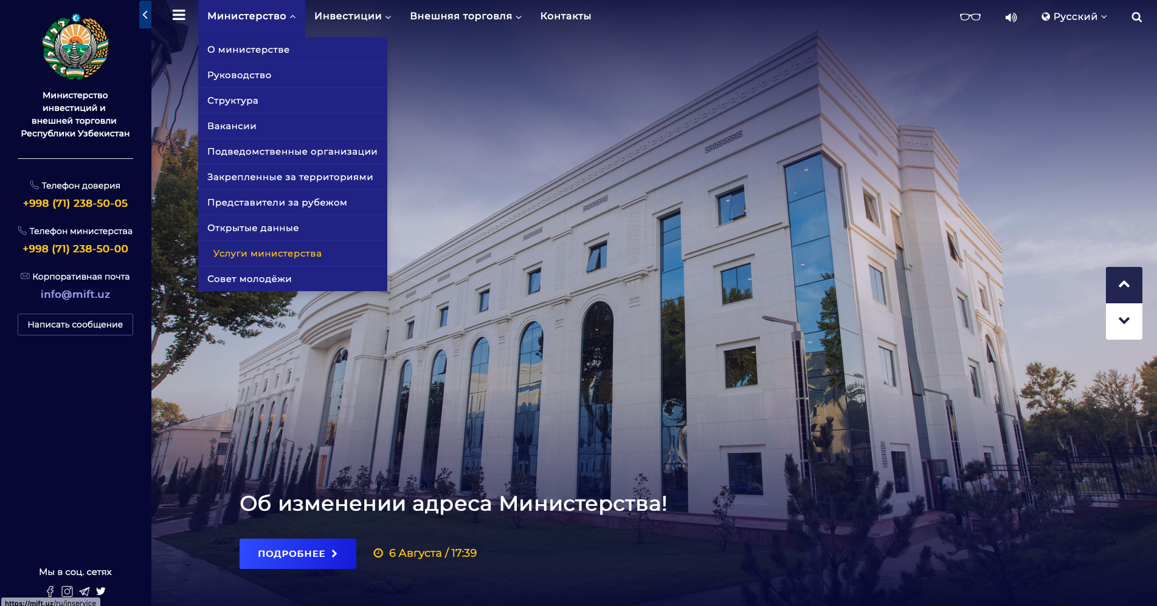

Step 2: Select the type of interactive services – “Applications for registration of contracts” («Заявки на регистрацию контрактов») (See Figure 2).

Figure 2. Interactive services

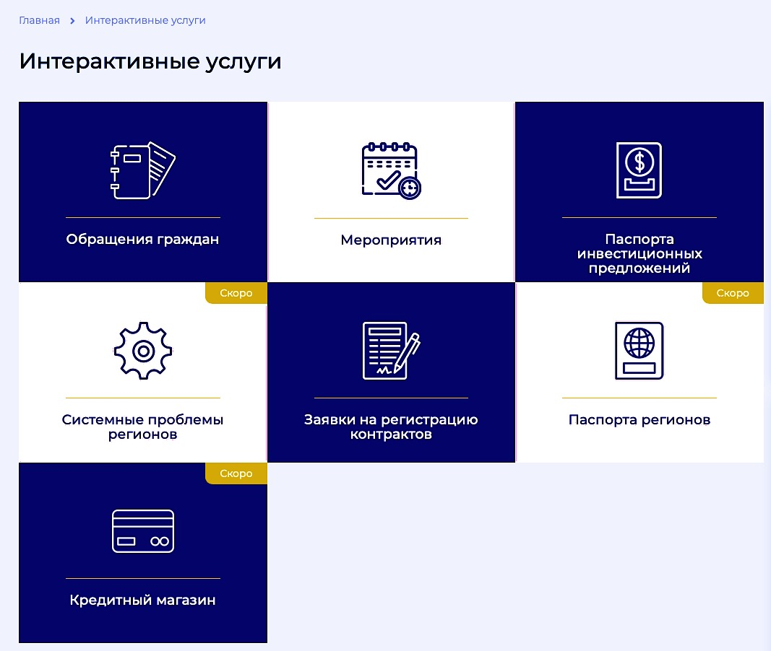

**Step 3:** Select the desired task “Fill in application”, “Change application” or “Check the status” depending on the purpose. (See Figure 3)

**Figure 3. Application filling**

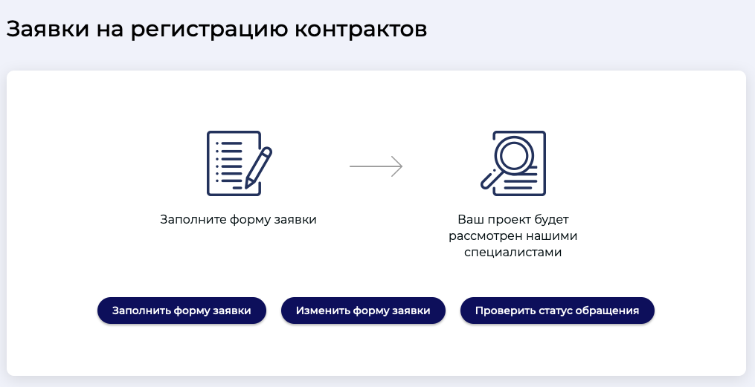

Fill in application Change application Check the status

Your project will be considered by our specialists

Fill in application

Applications for contracts’ registration

* "Fill in application" is used for the initial submission of documents package for registration;
* "Change application" is used when making adjustments, changes, additions according to the comments submitted during the registration of submitted contracts / additional agreements;
* “Check the status" is used when reconciling the stages and status of the registration of submitted contracts / additional agreements.

Step 4/1: When initially submitting documents for registration, please, fill in the application specifying the following data.

|  |  |  |  |
| --- | --- | --- | --- |
|  | Name of column | Filling details | Example |
| Part I | | | |
|  | Name of Project Initiator | name of the Ministry and Department (Project Initiator) according to the directory.  If there is no, or there is improper name of Project Initiator (Employer) in the directory, please, apply to Admin user of this section, employee of the Department for Feasibility Studies Assessment and MIFT bidding coordination (For enquiries, call: 71 2385216, e-mail: mf195@mift.uz) | The Ministry of Investment and Foreign Trade of the Republic of Uzbekistan |
|  | Specify No. and date of outgoing letter of the Project Initiator/Applicant | outgoing number of Application without No. | UT-06/2 |
|  | Contact numbers of the Project Initiator/Applicant | correct contact details of the contractor or responsible person in Cyrillic (full name, phone number with code) | (97) 4354110 |
|  | Full name of contact person | Ahmedova Guzal Rustamovna |
|  | E-mail | correct e-mail of either the Project Initiator or the responsible person.  Reference: if the documents package is incomplete, or there is non-compliance during registration, the MIFT shall be entitled to send comments and notes to e-mail specified in the application form. In addition, you will receive the awarded reference number and password to your e-mail, which is used to track the status of the application after successful acceptance of online application. Therefore, specify the correct and accurate e-mail. Only one email address may be included. You can specify e-mail not linked to the corporate mail of the Project Initiator. | eguzal2015@mail.ru |
| Part II | | | |
|  | Contract or additional agreement | name of document sent for registration. When selecting the type of document, the columns for numbers and dates of contracts/additional agreements without No. are opened | Additional agreement  MI/19/01  August 1, 2019 |
|  | Name of Employer | full name of the ministry and department, which is the Employer in the contract/ additional agreement without quotation marks | The Ministry of Investment and Foreign Trade of the Republic of Uzbekistan |
|  | Name of Contractor / Supplier/Consultant | Full name of the contractor based on the selection results without quotation marks. In the case of a consortium, first - full name of the consortium leader, then full names of the consortium partners without quotation marks and countries of origin separated by a comma.  In both cases, it is possible to specify the form of incorporation. | Huawei Technologies  In the case of a consortium:  Mitsubishi Heavy Industries, Mitsubishi Corporation |
|  | Country of origin | Contractor's country of origin according to the directory. In the case of a consortium, specify country of origin of the leader | Japan |
|  | Name of the contract/delivered goods/ services / "turnkey" works under the project | Full name of the purchase without quotation marks | Purchase of specialized equipment for the International Business Center  Selection of consulting company to develop the project's feasibility study and for supervision |
| Part III | | | |
|  | Project name | name of the project according to the directory. If there is no, or there is improper name of Project in the directory, please, apply to Admin user of this section, employee of the Department for Feasibility Studies Assessment and MIFT bidding coordination (For enquiries, call: 71 2385216, e-mail: mf195@mift.uz) | Equipment of The International Business Center |
|  | Currency | Select the currency of the contract according to the directory. If you define multiple currencies, click the "add currency" button | Euro |
|  | The value of the contract/additional agreement | Insert the contract value in numerals. When registering an additional agreement, specify the value of the main contract to which the additional agreement refers. If the content of the additional agreement includes a change in the initial value of the contract, then indicate the contract value considering price adjustments. | 232,500.35 |
|  | Source of contract / additional agreement financing | name of financing source according to the directory. If there is no, or there is improper name in the directory, please, apply to Admin user of this section, employee of the Department for Feasibility Studies Assessment and MIFT bidding coordination (For enquiries, call: 71 2385216) | [International Development Association](https://ru.wikipedia.org/wiki/%D0%9C%D0%B5%D0%B6%D0%B4%D1%83%D0%BD%D0%B0%D1%80%D0%BE%D0%B4%D0%BD%D0%B0%D1%8F_%D0%B0%D1%81%D1%81%D0%BE%D1%86%D0%B8%D0%B0%D1%86%D0%B8%D1%8F_%D1%80%D0%B0%D0%B7%D0%B2%D0%B8%D1%82%D0%B8%D1%8F) (IDA) |
|  | List of documents attached | download the required documents specified in the Chapter 1 "Preparation" hereof. When accepting the application, the program independently sends the attached documents to the MIFT's office for duly registration. Up to 15 files can be attached. The files size should not exceed 25 MB. Available formats: * doc, *.xls, *.pdf | application.pdf 0.7 MB  additional agreement.pdf 96.3Kb  etc. |
|  | Required captcha | | 51112 |
|  | Confirmation that the information provided is true, complete and accurate | | By clicking |

Note. The data specified in the application are reflected in the final letter of MIFT, which is the confirmation of contract/additional agreement registration. Accordingly, when filling in the application, it is necessary to specify complete and correct data, otherwise, errors may be made when executing response that cannot be corrected.

Step 4/2: During correction, adjustment or addition after the MIFT's comment:

* remove comments from the MIFT;
* enter the awarded reference number and password previously sent to e-mail specified in the application in "Fill in application" column;
* correct data in the application, delete documents to be corrected and attach corrected or missing documents.

When entering the captcha and confirming that the information submitted is true, complete and accurate, the screen displays a confirmation of the successful operation as "updated" (See Fig. 4).

**Fig. 4 Updated**

Updated

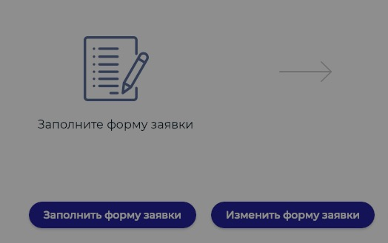

If the Applicant does not agree with the MIFT's comments, he/she may contact the Admin user of this section, employee of the Department for Feasibility Studies Assessment and MIFT bidding coordination (For enquiries, call: 71 2385216, e-mail: [mf195@mift.uz](mailto:mf195@mift.uz)) and prove its arguments. Otherwise, he/she may send the arguments in writing.

**Step 5.** Following the confirmation of acceptance of the electronic application, the Applicant receives the application number. The application number and password will be sent to e-mail specified in the Application. Every application should be awarded with a certain application number and a password.

The Applicant shall be entitled to verify the status of his/her document by going to “Check the status of application” and entering application number and password previously obtained by e-mail.

**Statuses:**

* “In progress” - the Applicant is expected to make corrections according to the comments from the MIFT;
* "Failure" - a response on refusal to register the forwarded contract / additional agreement with justification was sent;
* “For approval” - documents in full are under the approval by the MIFT;
* “Registered” - the document is registered in the MIFT.

**Chapter 2. Registration of contract/  
additional agreement**

According to the results of a positive consideration the duly procedure involves:

a letter from the MIFT on registration of contracts/additional agreements specifying awarded number and date of registration;

signing of the letter by the Deputy Minister of MIFT supervising the Department for Feasibility Studies Assessment and MIFT bidding coordination

filling in the Registry of contracts/additional agreements to be registered;

submission of letter original to the representative of the Applicant (Project Initiator, Employer) by proxy or upon a certificate against signature in the Registry;

duly saving of letter copy with documents submitted in the MIFT.

If there are questions on registration of the contract/additional agreements, the Applicant may contact the Admin user of this section, employee of the Department for Feasibility Studies Assessment and MIFT bidding coordination (For enquiries, call: 71 2385216, e-mail: [mf195@mift.uz](mailto:mf195@mift.uz)).